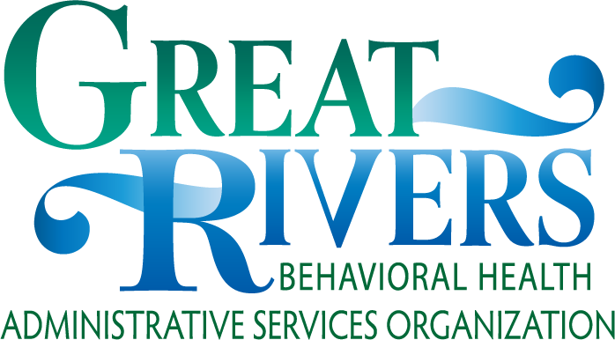

The Great Rivers BH-ASO Regional and Local FYSPRTs are sponsored by DBHR and the Children’s Behavioral Health Executive Leadership Team.

Resources

Regional FYSPRT Information
https://www.grbhaso.org/fysprt

Statewide FYSPRT Information
https://www.hca.wa.gov/about-hca/ behavioral-health-recovery/family- youth-system-partner-round-table-
fysprt
Point of Contact:
Kari Goudge
By Email:
kgoudge@grbhaso.org

Phone
503 680 6625

www.grbhaso.org

FYSPRT
Family, Youth & System Partner Round Table

Scan the QR code with your phone to visit our website

FYSPRT Advocacy Statewide Changes

For more information: www.grbhaso.org
What is the FYSPRT?

The Family, Youth & System Partner Round Table (FYSPRT) is a forum for family, youth, behavioral health (BH) system partners, and community partners to come together in a collaborative and strength-based environment. Together, we are building a collective community voice regarding decisions made about youth/family behavioral health services in Washington State.

FYSPRT Vision

The Regional FYSPRT is a coordinated network of youth, families, and system partners that come together to improve quality of care and access to services/resources for youth and families. Learn from youth/families struggling with behavioral health issues. The FYSPRT Vision upholds the System of Care core principles of being:
- Community-based
- Culturally and linguistically appropriate
- Family-driven
- Youth-guided

FYSPRT Mission

Using system/community partner relationships, personal expertise and/or lived experience to have safe, healthy, and thriving communities for all citizens.

Connecting with others in support, understanding, compassion, education, information sharing, and advocacy.

Participating in collaborative communication among system partners and our local communities.

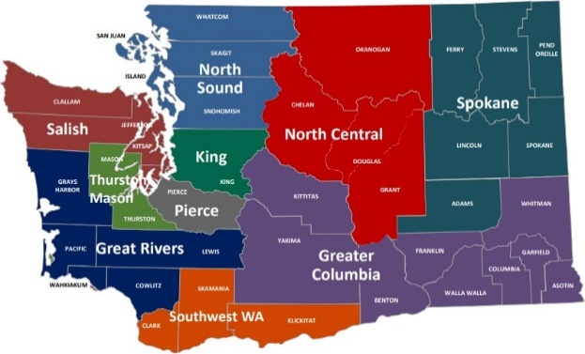
Map of FYSPRT Regions

- Parent-Initiated Treatment (PIT) now expanded to Family-Initiated Treatment (FIT) for youth over 13 years old who meet criteria various BH services.
- 71 WISe provider sites in Washington State as of 11/2019. All 5 counties in Great Rivers ASO’s region have multiple WISe providers.
- The WA Health Care Authority (HCA) Youth Peer Toolkit has been developed and distributed to empower Youth Peers in joining and succeeding in the workforce.
- The Office of Homeless Youth is currently working on passing a Substitute Senate Bill 6560 to ensure that youth: have effective transitions between BH providers, establish community connections/resources and have housing. The goal (for 2021) is that no youth is discharged from care into homelessness, and without community supports.

