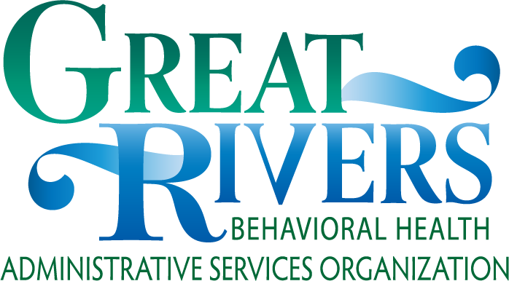
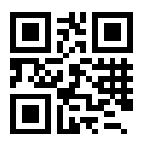

The Great Rivers BH-ASO regional and local FYSPRTs are sponsored by DBHR and the children’s behavioral health executive leadership team.

Resources

Regional FYSPRT Information
https://www.grbhaso.org/fysprt

Statewide FYSPRT Information
https://www.hca.wa.gov/about-hca/ behavioral-health-recovery/family- youth-system-partner-round-table-
fysprt

Scan the QR barcode to access our website

For more information on:
Benefits of the FYSPRT for Tribes
Hosting FYSPRT Meetings
Local FYSPRT Meetings and locations near you
Availability of Reimbursements
Kari Goudge
kgoudge@grbhaso.org
503-680-6625

FYSPRT
Family, Youth & System Partner Round Table
Tribal Engagement

FYSPRT Advocacy Statewide Changes

What is FYSPRT?
The Family, Youth & System Partner Round Table (FYSPRT) is a forum for family, youth, behavioral health (BH) system partners, and community partners to come together in a collaborative and strength-based environment. Together, we are building a collective community voice regarding decisions made about youth/family behavioral health services in Washington State.

FYSPRT Vision
The Regional FYSPRT is a coordinated network of youth, families, and system partners that come together to improve quality of care and access to services/resources for youth and families. Learn from youth/families struggling with behavioral health issues. The FYSPRT Vision upholds the System of Care core principles of being:
- Community-based
- Culturally and linguistically appropriate
- Family-driven

For more information: www.grbhaso.org
- Youth-guided

FYSPRT Mission
Using system/community partner relationships, personal expertise and/or lived experience to have safe, healthy, and thriving communities for all citizens.
Connecting with others in support, understanding, compassion, education, information sharing, and advocacy.
Participating in collaborative communication among system partners and our local communities.

Map of FYSPRT Regions
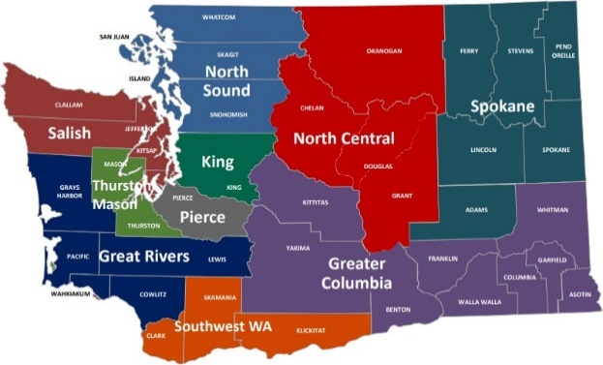

Parent-Initiated Treatment (PIT) now expanded to Family-Initiated Treatment (FIT) for youth over 13 years old who meet criteria various BH services.

